A REPORT ON DATABASE MANAGEMENT SYSTEM OF
SOUTH EAST BANK LIMITED

Course title: Database Systems Project / Fieldwork
Course No.: CSE 3102
Submitted By:
Khandker M. Qaiduzzaman
ID: 110229

Rezoana Ahmed
ID: 110234

Samapti Mandal
ID: 110251
Submitted To:
Dr. Md. Anisur Rahman
Professor
CSE Discipline
Khulna Univesity

Md. Zahidul Islam
Assistant Professor
CSE Discipline
Khulna University
Khulna University

Date of Submission: November 14, 2013
Query:
1. Search all information of customers from Customer Table:
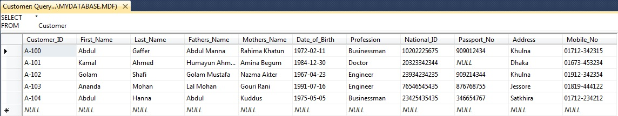

2. Search Customer_ID, First_Name and Last_Name of all customer from Customer Table:
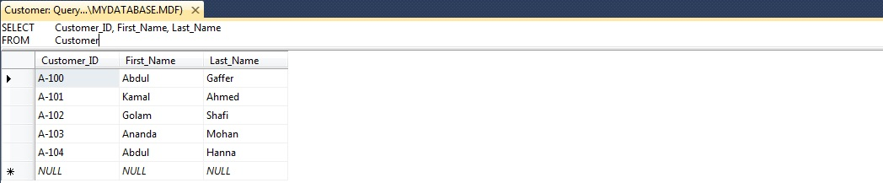

3. Search Customer_ID and Date_of_Birth of a customer whose Last_Name is ‘Gaffer’ from Customer Table:
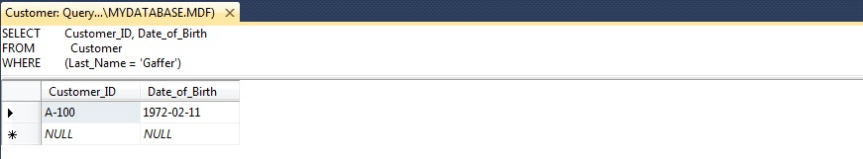

4. Search Customer_ID, First_Name, Last_Name and Date_of_Birth of a customer from Customer Table, whose National_ID is ‘10202225675’ and Passport_No. is ‘909012434’:
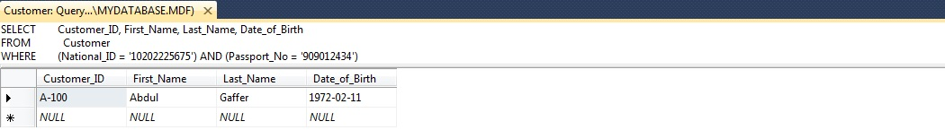

5. Search the information of all customers who are from ‘Dhaka’ or ‘Khulna’ from Customer Table:
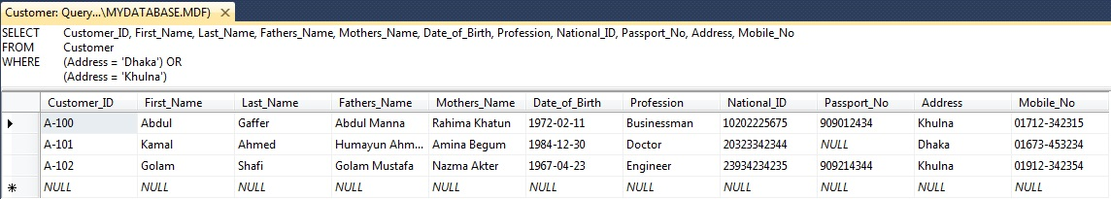

6. Insert values in Account_No, Balace and Account_Type of a customer:
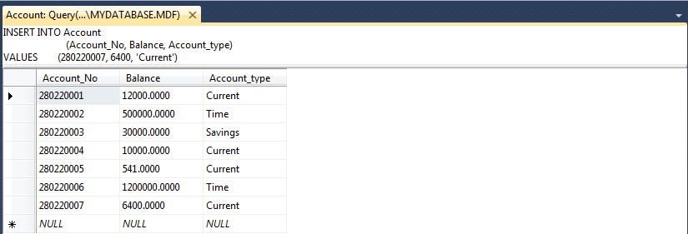

7. Update Account_type of Account_No. ‘280220002’:
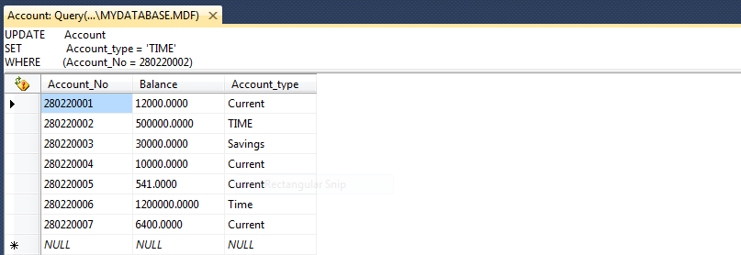

8. Delete all data of a row from Account Table where Account_No is ‘280220007’:
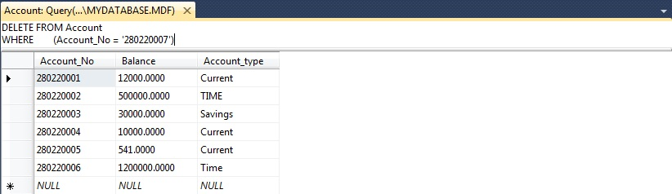

9. Find Top two customers who have Balance more than 1,00,000:
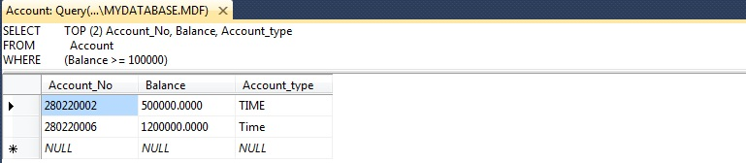

10. Search Customer_ID, First_Name, Last_Name, Father’s_Name, Mother’s_Name, Date_of_Birth, Profession and Address Ordered by Last_Name:
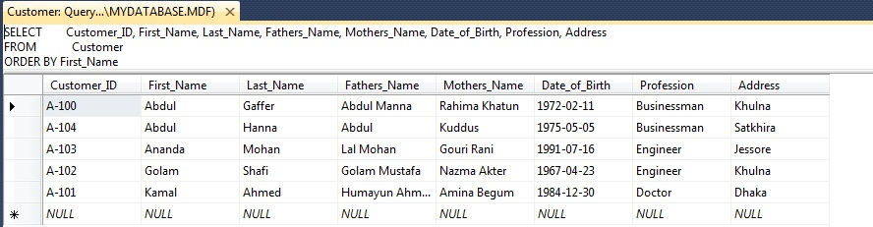

11. Find the category of Professions only from Customer Table:
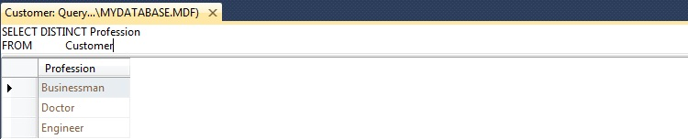

12. Sort the Balance in ascending order from Account Table:
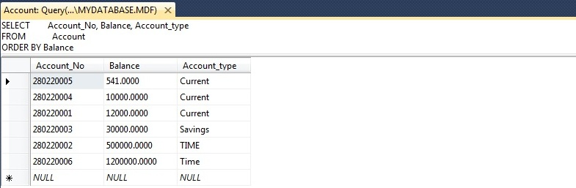

13. Search Customer_ID, First_Name and Last_Name of the customers where First_Name of a customer has ‘am’ at any position:
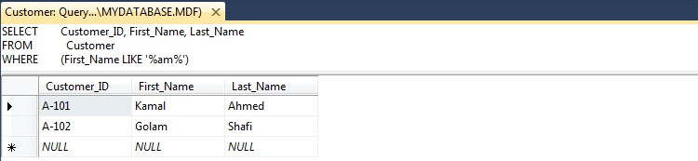

14. Cross join two Tables – Customer and Account:
